You are given a **0-indexed** string s that you must perform k replacement operations on. The replacement operations are given as three **0-indexed** parallel arrays, indices, sources, and targets, all of length k.

To complete the ith replacement operation:

1. Check if the **substring** sources[i] occurs at index indices[i] in the **original string** s.
2. If it does not occur, **do nothing**.
3. Otherwise if it does occur, **replace** that substring with targets[i].

For example, if s = "abcd", indices[i] = 0, sources[i] = "ab", and targets[i] = "eee", then the result of this replacement will be "eeecd".

All replacement operations must occur **simultaneously**, meaning the replacement operations should not affect the indexing of each other. The testcases will be generated such that the replacements will **not overlap**.

* For example, a testcase with s = "abc", indices = [0, 1], and sources = ["ab","bc"] will not be generated because the "ab" and "bc" replacements overlap.

Return *the* ***resulting string*** *after performing all replacement operations on* s.

A **substring** is a contiguous sequence of characters in a string.

**Example 1:**

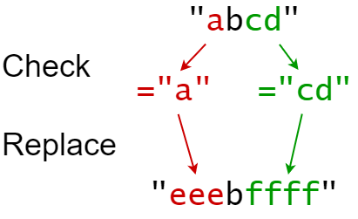

Input: s = "abcd", indices = [0, 2], sources = ["a", "cd"], targets = ["eee", "ffff"]  
Output: "eeebffff"  
Explanation:  
"a" occurs at index 0 in s, so we replace it with "eee".  
"cd" occurs at index 2 in s, so we replace it with "ffff".

**Example 2:**

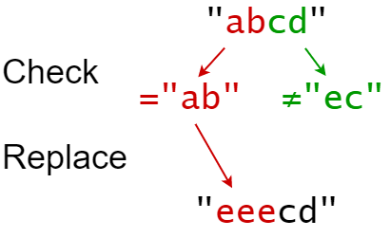

Input: s = "abcd", indices = [0, 2], sources = ["ab","ec"], targets = ["eee","ffff"]  
Output: "eeecd"  
Explanation:  
"ab" occurs at index 0 in s, so we replace it with "eee".  
"ec" does not occur at index 2 in s, so we do nothing.

**Constraints:**

* 1 <= s.length <= 1000
* k == indices.length == sources.length == targets.length
* 1 <= k <= 100
* 0 <= indexes[i] < s.length
* 1 <= sources[i].length, targets[i].length <= 50
* s consists of only lowercase English letters.
* sources[i] and targets[i] consist of only lowercase English letters.